**Analysis of Gene Expression across Time in Hematopoietic Cell Development**

Varun Gupta1* and Kapil Kanagal1

1 Department of Statistics, Stanford University, 592 Mayfield Avenue, Stanford, CA 94309

*To whom correspondence should be addressed. Email: vgupta16@stanford.edu

**________________________________________________________________________________________________________**

**I. Background**

The use of single-cell gene expression analysis of embryonic progenitor cells can aid in determining the molecular pathways that control organ development. Single-cell gene expression analysis has already been used to study transcriptome dynamics during embryonic development; analysis has successfully identified clusters of co-expressed genes and their leading hub genes during preimplantation in mouse and human development[1], cell fates from zygote to blastocyst according to particular transcription factors[2], and differences between the gene expression signatures of human epiblast and in vitro hematopoietic stem cells.[3] In particular, blood, or hematopoietic stem cells, can be used to study organ development due to recent technical advances in improving its accessibility and the availability for markers of specific embryonic cell populations[4], as demonstrated by recent identifications of lineage commitment[5] and transcriptional regulatory[6] events in blood. Moreover, blood development occurs early enough during organogenesis, as primitive erythrocytes are required to support the growing embryo.[7]

Given such success in single-cell expression analysis, Moignard et al. inspected hematopoietic development in the mouse embryo through unsupervised analyses of a dataset of 3,934 cells “with blood-forming potential captured at four time points between E7.0 and E8.5” and their levels of expression for 46 different genes.[8] In particular, Moignard et al. used hierarchical (agglomerative) clustering, dimensionality reduction in the form of multidimensional scaling (MDS), diffusion mapping, and principal components analysis (PCA), and boolean network synthesis to reconstruct boolean update rules to analyze the molecular pathways behind development. They demonstrated that the Sox7 factor blocks primitive erythroid development and Sox and Hox factors control expression of the Erg factor. They also identified twenty highly connected transcription factors that stabilize in eight subclusters.

This project aims to develop a more basic understanding of the transcriptome dynamics in the mouse embryo over the given time period. Instead of using sophisticated unsupervised statistical learning methods, this project will focus on conducting tests of homogeneity and independence on the discretized setting of the data to identify factors that contribute the most to heterogeneity in gene expression levels over time and factors that are highly co-dependent during particular periods of time, respectively. Given these insights, our project will then quantify differences in factor expression and dependence from the continuous setting of the data using nonparametric tests such as the Wilcoxon signed-rank test and nonparametric methods such as bootstrapping. These more fundamental statistical tests will enable us to measure transcriptome changes that occur in cells transitioning from one period to the next and eventually differentiating into either endothelial or blood cells without making parametric assumptions.

The cells had 5 potential types along 4 different time periods, which represented the different stages in their differentiation. The cells could either be primitive streak (PS), neural plate (NP), head fold (HF), four somite putative blood cells (4SG), or endothelial Flk1+GFP- cells (4SFG-). A diagram of the cell differentiation pathway can be seen below:

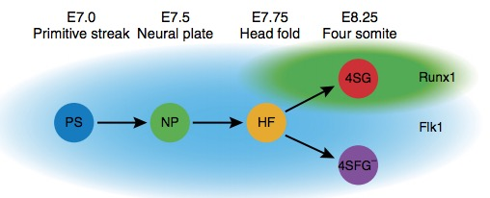

Figure 1: Cell differentiation pathway (Moignard, et. al 2013)

**II. Statistical Methods**

Multiple statistical methods are available for analysis of our data. Two primary parametric methods exist for measuring transcriptome changes over time. The first method is the “moderated t-test”, which is a variant of the simple t-test oriented to experiments with few biological replicates. The primary difference between the moderated t-test and the simple t-test is in the calculation of the variance. While the simple t-test calculates the variance from the data that is available for each gene, the moderated t-test calculates variance using information from all of the selected genes.[9] Even though this test is very effective in settings where normality is not exact, the data must still trend towards a normal distribution for it to be accurate. The second method involves the use of Analysis of Variance (ANOVA) to test linear contrasts of the means of several groups. As a parametric test, ANOVA requires prior knowledge about the distribution of our qPCR data. If our sample sizes are large enough, we can assume that our qPCR data is distributed normally.[10]

There also exist various nonparametric tests that can be used to analyze the data. In particular, a Chi-Squared Test of homogeneity could analyze the similarity in gene expression levels at different time periods for a given gene. This test would first create a contingency table that would contain genes as the rows and the cell types as the columns. Since the Chi-Squared Test of homogeneity is a nonparametric test, we can determine which genes are most actively contributing to the statistic without prior knowledge of the distribution. The null hypothesis for this test would be that the distribution of gene expression levels across time is the same for a given gene. The Chi-Squared test would be most beneficial when analyzing the binary data to analyze whether or not a gene is activated in a given cell type. Correspondence analysis can also be used on the *discrete data* to determine which genes contribute the greatest to inhomogeneity.

A Chi-Squared Test of independence could be used on the *discrete data* to determine if two genes in the same cell type are independent of one another. If the test statistic reveals that they may not be independent, we could use the bootstrap method on the *continuous data* to estimate the correlation between the two genes in a given cell type. Association plots can also be used on the *discrete data* to visualize the deviation from independence of particular genes in a given cell type.

Finally, a Wilcoxon signed-rank test could determine if the expression levels of a particular gene across time are drawn from the same population. With the same type of test, we could utilize the Hodges-Lehmann estimator to check if the location parameter for a gene at a given time period is zero. In effect, this test will replace the t-test to quantify the difference in expression levels for a given gene between cell types. These tests would be used on the *continuous* expression data, and the significance level would be adjusted accordingly using the highest significance level suggested by the following corrections: the Bonferroni correction, the Tukey procedure, and the Scheffé method.

To determine if a parametric or nonparametric test should be used with our data set, we analyze the size of our samples, relative to each gene in each different component of the cell differentiation. Since our data contained ~4,000 cells and will be tested for the independence and homogeneity of 46 genes across 5 different cell types, we see that each gene only has $\frac{3,934}{46×5}$ = 17.104 ≈ 20 cells in each given cell type. This means that our sample size (controlling for the genes and types of cells) is too small to assume a normal distribution for our qPCR gene expression data.[11] Parametric options will yield a higher power if the data is normally distributed, but as we are not necessarily able to assume normality, non-parametric options are preferred.

**III. Results and Discussion**

The binary data was created from 1,448 of the single gene changes that could be connected to form a single state graph. These expression states in the graph represent the largest connected component of the overall graph including all of the 3,934 binary states (binary states for all of the cells). The binary single-cell expression states correspond to the on and off patterns of transcription factor expression.

Chi-Squared Analysis

To perform the Chi-Squared Analysis, we first needed to convert the data into a readable format and then create a contingency table with the rows being the different genes and the columns being the different cell types (an indicator of the time, since the different cell types represent the differentiation from one cell type to another). First, the binary data was saved in a .csv file and was read into R. The data for each of the cells was then parsed and grouped into 5 different categories -- PS, NP, HF, 4SFGA, and 4SGA -- each representing a different cell type. Each of the categories had a recorded score equal to the sum of the number of cells that were activated above the given threshold for each gene. As a result, the contingency table looked as follows:

|  |  |  |  |  |  |
| --- | --- | --- | --- | --- | --- |
|  | 4SFGA | 4SGA | HF | NP | PS |
| Cbfa2t3h | 182 | 359 | 402 | 190 | 112 |
| Erg | 181 | 29 | 371 | 151 | 81 |
| Ets1 | 241 | 154 | 433 | 210 | 156 |
| Ets2 | 259 | 377 | 436 | 212 | 158 |
| Etv2 | 223 | 69 | 431 | 205 | 152 |
| Etv6 | 259 | 322 | 436 | 212 | 156 |
| Fli1 | 255 | 278 | 430 | 203 | 136 |
| FoxH1 | 250 | 382 | 436 | 212 | 158 |
| FoxO4 | 254 | 383 | 435 | 212 | 158 |
| Gata1 | 1 | 368 | 48 | 76 | 35 |
| Gfi1 | 5 | 18 | 59 | 70 | 26 |
| Gfi1b | 15 | 379 | 128 | 104 | 52 |
| Hhex | 244 | 177 | 416 | 192 | 122 |
| HoxB2 | 1 | 0 | 0 | 0 | 0 |
| HoxB4 | 160 | 10 | 297 | 127 | 62 |
| HoxD8 | 0 | 0 | 0 | 0 | 0 |
| Ikaros | 15 | 379 | 208 | 151 | 74 |
| Ldb1 | 253 | 379 | 432 | 211 | 158 |
| Lmo2 | 118 | 141 | 295 | 149 | 93 |
| Lyl1 | 214 | 353 | 393 | 178 | 101 |
| Mecom | 133 | 6 | 194 | 38 | 27 |
| Meis1 | 211 | 84 | 422 | 175 | 125 |
| Mitf | 28 | 152 | 71 | 32 | 28 |
| Myb | 34 | 320 | 218 | 138 | 85 |
| Nfe2 | 9 | 381 | 119 | 103 | 51 |
| Notch1 | 251 | 29 | 427 | 199 | 148 |
| Runx1 | 153 | 383 | 363 | 191 | 146 |
| Sfpi1 | 78 | 182 | 243 | 137 | 73 |
| Sox17 | 205 | 1 | 284 | 72 | 35 |
| Sox7 | 247 | 19 | 420 | 195 | 127 |
| Tal1 | 249 | 383 | 431 | 204 | 133 |
| Tbx20 | 170 | 16 | 377 | 184 | 150 |
| Tbx3 | 135 | 32 | 223 | 135 | 131 |

This contingency matrix contained zeros in the binary expression data with HoxB2 and HoxD8, so these two genes needed to be removed from the table to perform an accurate Chi-Squared analysis. The reason for their exclusion is their lack of expression across the different cell types, which might be due to biological regulation by other genes in the analysis or because they are generally not expressed in these cell types.

The modified contingency matrix was then used for Chi-Squared Analysis. First, we will examine a Chi-Squared test of homogeneity to determine, if for a given gene, there is similarity in gene expression levels across the different cell types (across time). Running a Chi-Squared test on the data in R yielded the following results:

X-squared = 4873.5, df = 120, p-value < 2.2e-16

Thus, as a result of the Chi-Squared test, we are able to reject our original null hypothesis that the distribution of gene expression levels across time are the same for a given gene, in favor of our alternative hypothesis that the gene expression levels for a given gene are not constant across time. Intuitively, this confirms what we would expect, since different cell types would naturally require genes to be activated at different levels in order to correctly function.

To better visualize and analyze which specific genes were contributing most highly to inhomogeneity, we performed a correspondence analysis along with multiple plots of our Chi-Squared Statistics, in which we plotted the Chi-Squared statistic after removing each gene individually. This allowed us to determine the genes that had the biggest impact on the statistic, which in turn told us which genes contributed the most to inhomogeneity. To control for the final differentiation (into either 4SG or 4SFG), we performed a Chi-Squared Analysis on the data after removing these two columns from the table. This would tell us which genes were most important in differentiation prior to the final differentiation, and which genes were most important in determining if an HF cell became an endothelial cell or an erythroid cell. By plotting the Chi-Squared statistics in the manner described above, we yielded the following two plots:

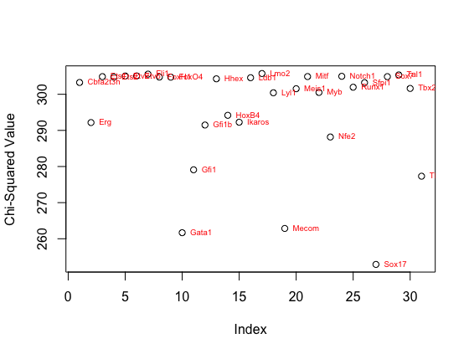

Figure 2: This graph represents the Chi-Squared Statistics of the table after removing the given genes *prior* to the final differentiation into an endothelial cell or an erythroid cell.

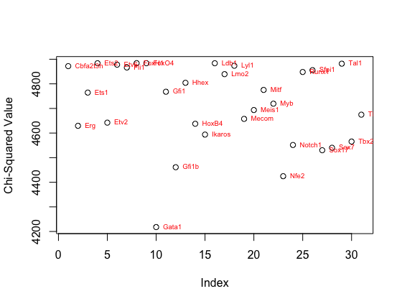

Figure 3: This graph represents the Chi-Squared Statistics of the table after removing the given genes *after* to the final differentiation into an endothelial cell or an erythroid cell.

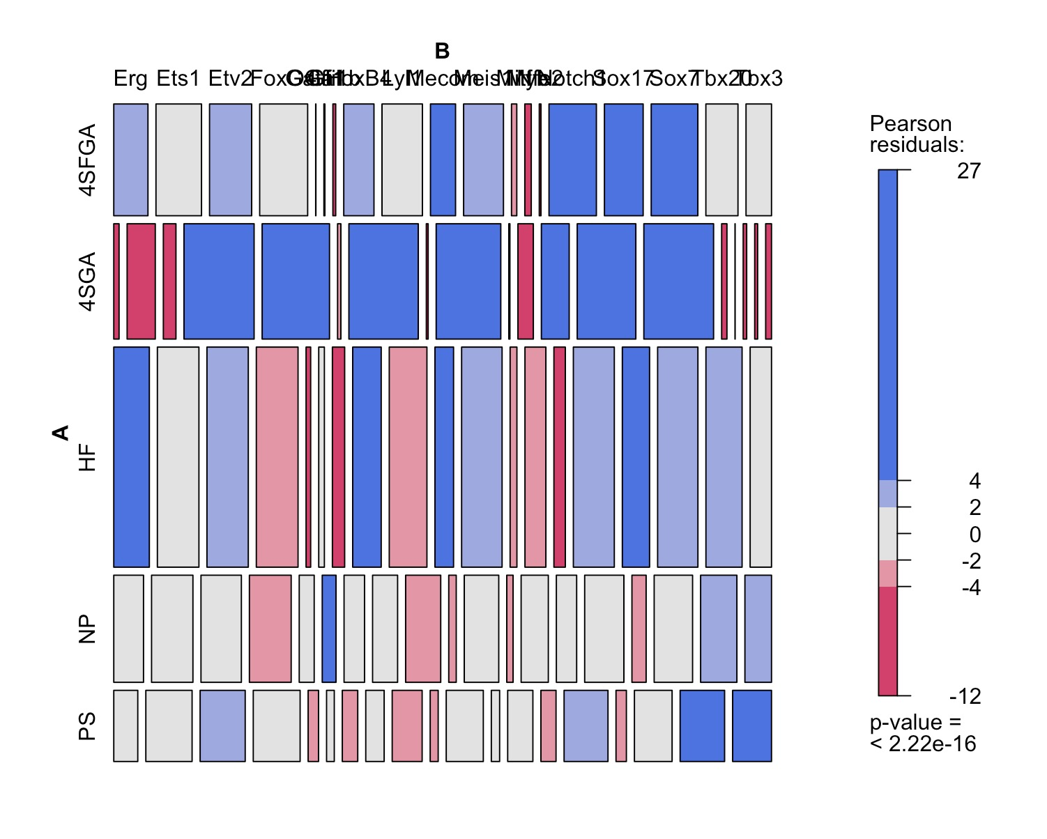 As a result of these two graphs, we were able to determine which genes have relatively the same level of impact on the Chi-Squared statistics both before and after the final differentiation. This allowed us to then label these genes as background genes that did not contribute heavily to inhomogeneity. This allowed us to then perform the rest of the analysis focusing only on the genes that actually contributed to inhomogeneity. We found that Cbfa2t3h, Ets2, Etv6, Fli1, FoxH1, Hhex, Ikaros, Ldb1, Lmo2, Runx1, Sfpi1, and Tal1 contributed the least to the inhomogeneity in the Chi-Squared statistic and as such, removed them from our data table before commencing with our mosaic plot and correspondence analysis. After doing this, our mosaic plot looked as follows:

We see from our mosaic plot that (....)

To determine specifically which genes contributed the most to inhomogeneity, we then used correspondence analysis and plotted the result of that, which yielded the following graph:

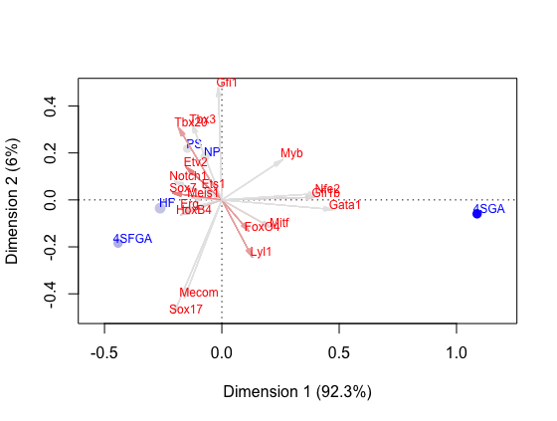

Figure 4: Correspondence Analysis Graph of Genes using Binary Data to determine which genes contribute the most to inhomogeneity.

From this plot, we see that Sox17, Mecom, Gata1, and Gfi1 contribute the most to inhomogeneity among the gene expression levels for a given gene across time. This result makes sense because Sox17 is a known factor that is key in the process of cell differentiation and therefore should be activated at higher levels than other genes in a given cell type. Furthermore, (more analysis)

We then performed a Chi-Squared test of Independence to determine if two genes in the same cell types operate independently of one another. We performed this for a specific subset of genes in the data, based on our correlation plot. We chose the genes to test our data on by first analyzing a correlation map of all the genes with one another. We then selected 3 highly/mid correlated genes and 1 low/uncorrelated gene to examine how high correlation and expression dependence were linked to one another. Sox7 was specifically chose because Moignard explains that it blocks preliminary erythroid development. It was tested against HoxB4 since Moignard further explains that Sox and Hox factors directly regulate the expression of the hematopoietic stem-cell regulator, Erg. Both Sox7 and HoxB4 are endothelial genes. Gata1 and Gfi1b were chosen since they both are hematopoietic genes. Notch1 and Ets1 were selected as random controls, since Moignard does not specifically examine these genes. Myb is also a hematopoietic gene, while Erg is an endothelial gene, so these two were tested to test and confirm their independent natures. We tested the following pairs of genes and obtained the corresponding Chi-Squared statistics and association plots:

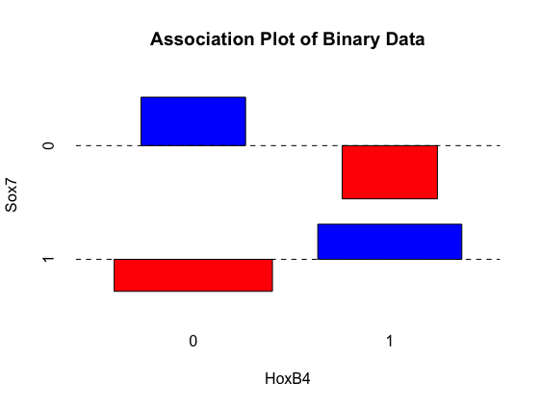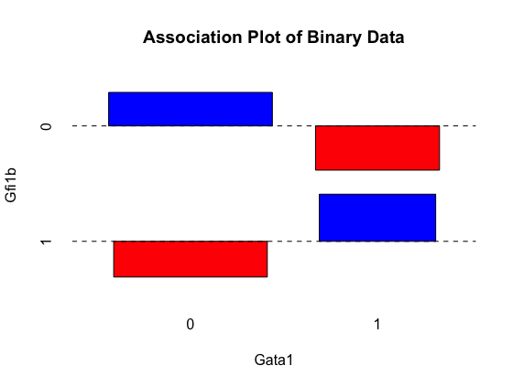

Figure 5: Association plot of Gata1-Gfi1b. X-squared = 829.81, df = 1, p-value < 2.2e-16

Figure 6: Association plot of HoxB4-Sox7. X-squared = 366.73, df = 1, p-value < 2.2e-16

From the Gata1-Gfi1b plot, we see that Gata1 and Gfi1b have more 0,0 and 1,1 associations than would be expected under the null distribution, with fewer 1,0 and 0,1 associations, for a given cell type. This implies that their expression levels are probably not independent from one another, which is confirmed by the small p-value for the Chi-Squared test.

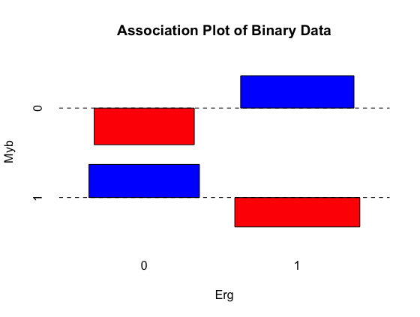We see a similar pattern in the HoxB4 and Sox7 Chi-Squared test of independence, in which the two genes have a high 0,0 and 1,1 association and a low 0,1 and 1,0 association. The p-value in this test is also extremely small implying that the expression levels of the two genes are probably dependent on one another.

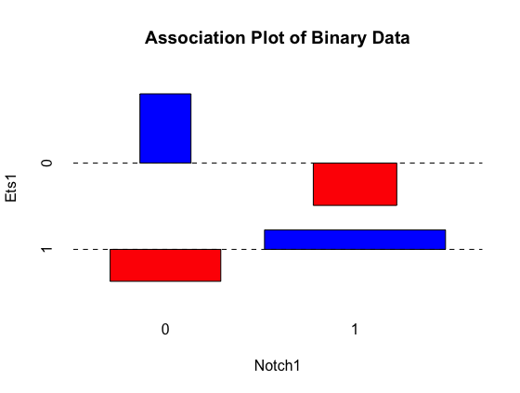

Figure 8: Association plot of Erg-Myb. X-squared = 10.103, df = 1, p-value = 0.00148

Figure 7: Association plot of Notch1-Ets1. X-squared = 552.47, df = 1, p-value < 2.2e-16

We see a similar trend with the association plot between Notch1 and Ets1, showing a dependency between the expression levels of these two genes with both the plot and the small p-value. This plot has different widths for the 0,0 and 1,1 associations because (EXPLAIN WHY THEY HAVE DIFFERENT WIDTHS)

This association plot and the corresponding p-value reveal that the expression levels or Erg and Myb are likely independent of one another, as the plot shows higher 1,0 and 0,1 expression levels for the two genes than would we expected under the null hypothesis.

We used a Bonferroni correction as a conservative correction for the p-value with which to determine significance. There were $(\begin{matrix}31 \\ 2\end{matrix}$) possible combinations which yielded a significance threshold of $\frac{0.05}{(\begin{matrix}31 \\ 2\end{matrix})}$ = 0.0001. As a result, we found that Gata1-Gfi1b, HoxB4-Sox7, and Notch1-Ets1 all had p-values well below this threshold implying that we could reject the null hypothesis that these pairs of genes were expressed independently from one another. However, Erg-Myb had a p-value above the threshold meaning we fail to reject the null hypothesis. As a result, we can see from the correlation graph that these two genes have a near 0 correlation implying that they might indeed be expressed independently of one another, since we fail say that these genes are necessarily dependent. These results are also visible from the association plots.

Furthermore, we used the bootstrap method to estimate the correlations between the various genes in each of the cell types. (Bootstrap)

Wilcoxon Signed-Rank Test

(Wilcoxon Results and Discussion)

**IV. Future Work**

(More future work)

**V. Works Cited**

Baron, M. H., J. Isern, and S. T. Fraser. “The Embryonic Origins of Erythropoiesis in Mammals.” *Blood* 119, no. 21 (May 24, 2012): 4828–37. doi:10.1182/blood-2012-01-153486.

Goni, Ramon, Patricia Garcia, and Sylvain Foissac. “The qPCR Data Statistical Analysis.” *Integromics*, September 2009.

Guo, Guoji, Mikael Huss, Guo Qing Tong, Chaoyang Wang, Li Li Sun, Neil D. Clarke, and Paul Robson. “Resolution of Cell Fate Decisions Revealed by Single-Cell Gene Expression Analysis from Zygote to Blastocyst.” *Developmental Cell* 18, no. 4 (April 2010): 675–85. doi:10.1016/j.devcel.2010.02.012.

Mahajan, Maya M., Betty Cheng, Ashley I. Beyer, Usha S. Mulvaney, Matt B. Wilkinson, Marina E. Fomin, and Marcus O. Muench. “A Quantitative Assessment of the Content of Hematopoietic Stem Cells in Mouse and Human Endosteal-Bone Marrow: A Simple and Rapid Method for the Isolation of Mouse Central Bone Marrow.” *BMC Hematology* 15, no. 1 (December 2015). doi:10.1186/s12878-015-0031-7.

Moignard, Victoria, Iain C. Macaulay, Gemma Swiers, Florian Buettner, Judith Schütte, Fernando J. Calero-Nieto, Sarah Kinston, et al. “Characterization of Transcriptional Networks in Blood Stem and Progenitor Cells Using High-Throughput Single-Cell Gene Expression Analysis.” *Nature Cell Biology* 15, no. 4 (March 24, 2013): 363–72. doi:10.1038/ncb2709.

Moignard, Victoria, Steven Woodhouse, Laleh Haghverdi, Andrew J Lilly, Yosuke Tanaka, Adam C Wilkinson, Florian Buettner, et al. “Decoding the Regulatory Network of Early Blood Development from Single-Cell Gene Expression Measurements.” *Nature Biotechnology* 33, no. 3 (February 9, 2015): 269–76. doi:10.1038/nbt.3154.

Pina, Cristina, Cristina Fugazza, Alex J. Tipping, John Brown, Shamit Soneji, Jose Teles, Carsten Peterson, and Tariq Enver. “Inferring Rules of Lineage Commitment in Haematopoiesis.” *Nature Cell Biology* 14, no. 3 (February 19, 2012): 287–94. doi:10.1038/ncb2442.

Smyth, Gordon K. “Linear Models and Empirical Bayes Methods for Assessing Differential Expression in Microarray Experiments.” *Statistical Applications in Genetics and Molecular Biology* 3, no. 1 (January 12, 2004): 1–25. doi:10.2202/1544-6115.1027.

Xue, Zhigang, Kevin Huang, Chaochao Cai, Lingbo Cai, Chun-yan Jiang, Yun Feng, Zhenshan Liu, et al. “Genetic Programs in Human and Mouse Early Embryos Revealed by Single-Cell RNA Sequencing.” *Nature* 500, no. 7464 (July 28, 2013): 593–97. doi:10.1038/nature12364.

Yan, Liying, Mingyu Yang, Hongshan Guo, Lu Yang, Jun Wu, Rong Li, Ping Liu, et al. “Single-Cell RNA-Seq Profiling of Human Preimplantation Embryos and Embryonic Stem Cells.” *Nature Structural & Molecular Biology* 20, no. 9 (August 11, 2013): 1131–39. doi:10.1038/nsmb.2660.

1. Xue et al., “Genetic Programs in Human and Mouse Early Embryos Revealed by Single-Cell RNA Sequencing.”
2. Guo et al., “Resolution of Cell Fate Decisions Revealed by Single-Cell Gene Expression Analysis from Zygote to Blastocyst.”
3. Yan et al., “Single-Cell RNA-Seq Profiling of Human Preimplantation Embryos and Embryonic Stem Cells.”
4. Mahajan et al., “A Quantitative Assessment of the Content of Hematopoietic Stem Cells in Mouse and Human Endosteal-Bone Marrow.”
5. Pina et al., “Inferring Rules of Lineage Commitment in Haematopoiesis.”
6. Moignard et al., “Characterization of Transcriptional Networks in Blood Stem and Progenitor Cells Using High-Throughput Single-Cell Gene Expression Analysis.”
7. Baron, Isern, and Fraser, “The Embryonic Origins of Erythropoiesis in Mammals.”
8. Moignard et al., “Decoding the Regulatory Network of Early Blood Development from Single-Cell Gene Expression Measurements.”
9. Smyth, “Linear Models and Empirical Bayes Methods for Assessing Differential Expression in Microarray Experiments.”
10. Goni, Garcia, and Foissac, “The qPCR Data Statistical Analysis.”
11. Ibid.